Write a program to find ceiling and floor value.

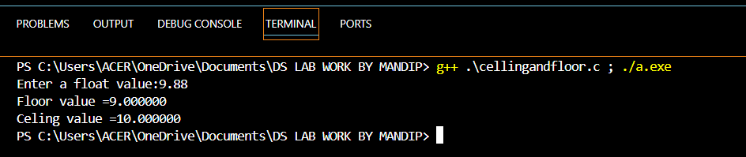

**Output:-**

Write a program to find Cartesian product of two set.

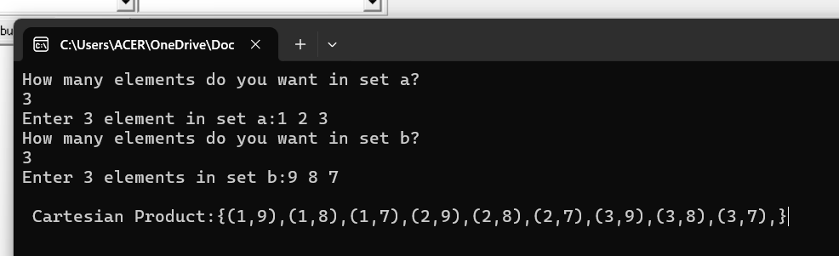

**Output:-**

WAP to calculate Addition subtraction division and multiplication of 2 number.

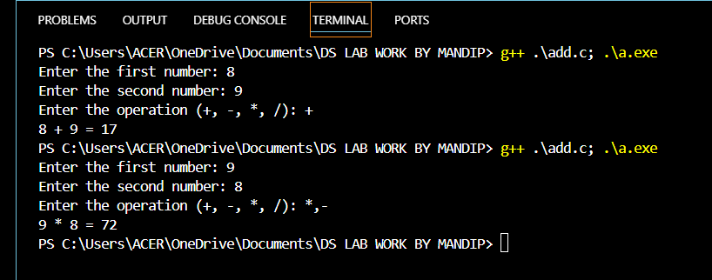 **Output:-**

Write a program to find to implement fuzzy set of operations.